NCEA Level 1 Assessment Resource| 4 Credits

Develop a computer system

This resource introduces the characteristics of the hardware components of a personal computer (PC), including peripherals, and how data flow between them. It considers the limitations and interoperability of each component. Interoperability is the ability to exchange and use information, usually in a large network made up of several local area networks. Students will be advised of the importance of following correct procedures and protocols when installing or replacing a component or a program. Students may complete this chapter individually, in pairs or in groups of three.
Basic digital infrastructure system
A basic digital infrastructure system consists of:
- Personal computer hardware
- Associated peripherals
- System software.
Personal computer hardware includes, but is not limited to:
- Case
- Power supply
- Motherboard
- On-board components (e.g. video, USB ports and networking)
- CPU
- Memory
- Extension cards (e.g. PCI Express)
- Storage devices (includes magnetic, optical and solid state drives and media).
Associated peripherals include, but are not limited to:

- keyboard and mouse
- CRT and LCD monitors
- Printer
- Modem or router
- At least one additional input device
- At least one additional output device.
System software includes, but is not limited to:
- Operating system
- Device drivers
- Disk utilities
- Malware/virus checkers.

Characteristic of components
Characteristics of components are the technical specifications of components that govern how they interact with other components.

Procedures
A procedure is a sequence of steps that can be followed to install or replace a component.
Protocols
A protocol is a sequence of steps that must be followed to install or replace a component.
Introduction to a computer digital infrastructure
When you turn your PC on — i.e. when you ‘boot’ it — the electrical current activated runs through a sequence of components and a check is made whether all of them are working correctly.
The ‘basic input/output system‘(BIOS) checks that the all the necessary components are connected and working.
These components are:
- Central processing unit (CPU)
- Keyboard
- Mouse
- Screen — monitor or visual display unit (VDU)
- Printer

In the 20th century, if a printer was not connected to a PC at the time of initial start-up, the PC would not recognise the printer when it was later connected. You had to connect the printer, close all programs and reboot the PC so that the BIOS would register the connection. This frustrating problem generally does not exist with modern computers. In the 21st century, PCs recognise when another component - peripheral — is added, and may automatically upload any new hardware program that is required to ensure the component works properly.
The problem concerning the failure of a computer to recognise a new connection should be kept in mind as you are working through this chapter, because it illustrates just how ‘stupid’ a PC can be.
- A PC can only follow the sequence of commands given. It follows these commands ‘to the letter’, never deviating or considering other possibilities.
- If the programmed commands miss out a possible event, such as accepting the connection of a printer after booting, the PC will not respond to the new event. The PC remains unaware that another cord has been connected to it.
Keep this literal processing of commands in mind as you work with computers. lt will help you to recognise when you, the commander, have failed to provide sufficient orders.

Task 1 | History of computers

PCs did ‘not just happen’. They evolved over decades, with their origins traceable in the many mechanical devices constructed to manipulate numerical data. To read more about the history of computers, go to the following websites.
- http://inventors.about.com/library/blc0index.htm
- http://en.wikipedia.org/wiki/Computer — follow the links to learn more about computers in general.
- https://www.computerhope.com/history/ the internet and games history includes surprising information.
- http://www.computersciencelab.com/ComputerHistory/History.htm — includes wonderful graphics from the abacus to the first ‘desktop’ computer.
List other websites that you find interesting and informative. You may wish to refer to them later.
Website URL | Information (what it’s about)

Task 2 | Components inside a PC

Go to the following websites and discover the essential components of a PC.
- https://en.wikibooks.org/wiki/Wikijunior:How_Things_Work/Computer
- http://howthingswork.org/electronics-how-computer-works/
- http://en.wikipedia.org/wiki/Computer
- https://www.factmonster.com/math-science/how-do-computers-work
- https://www.khanacademy.org/computing/computer-science/how-computers-work2/v/khan-academy-and-codeorg-introducing-how-computers-work
- https://www.explainthatstuff.com/howcomputerswork.html

Task 3 | Storage Devices

In the spaces following, draw or paste pictures of the following data storage devices. Label them and state whether they save data magnetically, optically or electronically.
1. CD/DVD | 2. External hard drive
- Saves data: | - Saves data:

3. Pen drive/USB stick | 4. Solid state drives (SSD)
- Saves data: | - Saves data:

Task 4 | Computer Components

Complete the following table.

Digital infrastructures: Computer components

Image | Component Name | Purpose
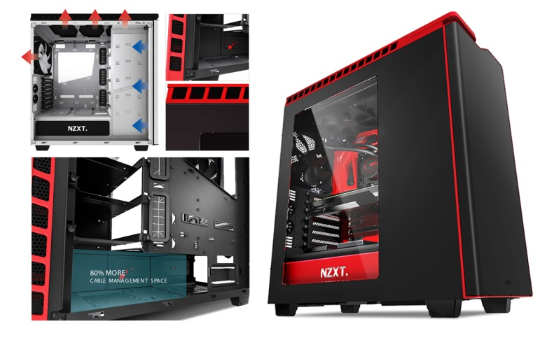 | Systems unit /  computer case  ³  (This is to show reference for image, points to webpage URL below table. Add for all your images and data) | Contains and protects the essential processing components such as power supply, CPU, video cards, USB ports. ²
 | Power supply
 | Motherboard
 | Video card(s)
 | USB ports
 | Networking ports
 | CPU
Memory
RAM
Memory
ROM
 | Extension card slots
 | Flash / Pen Drive
 | External hard drive
Modem:
- External
- Internal
 | Keyboard
 | Mouse
 | Monitor
 | Printer
 | Router
¹ Google images — all graphics were filtered under Advanced Image Search’ as ‘available for reuse‘
² http://en.wikipedia.0rg/wiki/Computer_case
³ https://iowacitytechnologyservices.files.wordpress.com/2014/08/20140823sa-nzxt-computer-case-h440-steel-mid-tower-black-008.jpg

Task 5 | System Software

Complete the table by stating the purpose of each type of software and providing at least two examples of each type of software.
Digital infrastructures: Personal Computer Systems Software

Software | Purpose | PC Examples
Operating Systems
Device Drivers
Malware / Virus Checker

Task 6 | Data flow through a PC

Connections and data ﬂow between computer components
All computer data flows through the CPU. A very simplistic representation follows.

Input  via:  - mouse  - keyboard  - portable data storage device  - scanning device  - internet |  | Processing  within CPU:  - control unit  - arithmetic logic unit  - registers  - clock |  | Output  to:  - monitor  - printer  - portable data storage device  - internet

For more information, read the information contained on the following web pages.
- http://www.ehow.com/about_5419075_parts-computer-cpu.html
- http://wiki.answers.com/Q/How_does_data_flow_or_move_between_the_different_components_of_your_personal_computer#ix2zl ArYOTJQ3
- http://www.webopedia.com/TERM/I/IRQ.html
- http://en.wikipedia.org/wiki/Northbridge_(computing)
- http://en.wikipedia.org/wiki/Southbridge_(computing)
- https://en.wikipedia.org/wiki/Platform_Controller_Hub

How and why connections and data ﬂow occur
The following bullet points outline how data flows within your PC.
- Striking a key, clicking a mouse or activating another input device sends an electronic signal/command from that peripheral through an interrupt request line (IRQ) to the input device controller.
- The input device controller sends the signal/command to the interrupt controller.
- The interrupt controller sends the signal/command to the CPU.
- The CPU stops the task that it is currently doing, filing this task where it can find it once the new command has been executed.
- The CPU checks where the signal/command has come from and refers to the interrupt descriptor table (IDT) in its memory to see what it must do.
- The interrupt service routine (ISR) tells the CPU what it must do.
- After the CPU has completed this new command, the return from interrupt (RET - Return from interrupt) tells the computer that it may return to the task it was doing (and filed away) before the new command interrupted it.
Without a structured process for dealing with storing current signals/commands and interpreting new signals commands, a computer would become confused and stop working.
Use the space following to draw a diagram illustrating the data flow listed above. You may like to be creative and draw the CPU as a person or alien.

Northbridge and Southbridge chip set
All the hardware components of a computer are linked through electronic wiring. Because the tasks performed by a computer are so numerous and are required to be accomplished at high speed, the CPU is helped by a chip set located on the motherboard. This set contains a Northbridge and a Southbridge.
The Northbridge (often called the memory controller hub — MCH) controls communication with the Southbridge and between those components which have the greatest processing demands — i.e. the CPU, RAM, BIOS, ROM and PCI Express video cards.
The Southbridge (otherwise known as the input/output controller hub — ICH) is further away from the CPU than the Northbridge. It controls communication with the Northbridge and among input/output devices that have slower processing demands.
Platform Controller HUB (PCH)
It is the successor to the Intel Hub Architecture, which used a northbridge and southbridge instead, and first appeared in the Intel 5 Series. The PCH controls certain data paths and support functions used in conjunction with Intel CPUs. These include clocking (the system clock), Flexible Display Interface (FDI) and Direct Media Interface (DMI), although FDI is only used when the chipset is required to support a processor with integrated graphics.

Task 6 | Technical characteristics of a PC

A closer look at personal computer components
Using the internet, complete the following Digital infrastructure: A personal computer table. The first two components have been done for you. Add further details that you consider essential on the lines provided at the end of the table. It is recommended that you complete this Task in pairs or in a group of three or four, splitting the components between you.

Digital infrastructures: A Personal Computer

Component | Technical Characteristics | Connection and data flow
Case /  Systems unit | - Enclosed protective body, often of thin steel or hardened plastic.  - Slots where all essential components (e.g. motherboard, expansion slots, power supply and fan) can be secured.  - Air-flow vents.  - Connection ports/sockets for power supply and peripheral devices.  - On/off button/switch at the front of the unit.  - CD/DVD player externally accessible.  - Reasonably lightweight and small for desktop use.  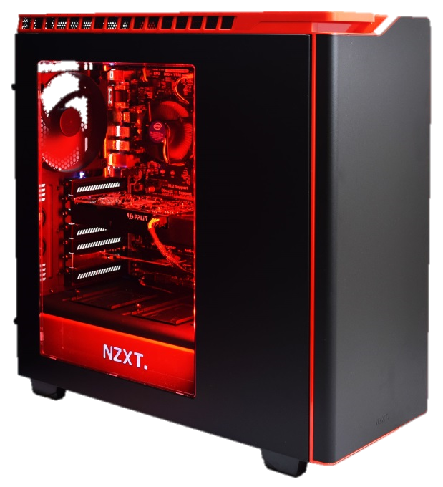 | How interoperability is ensured  Internal components are anchored into the case and linked through circuits. Connection sockets allow power and peripherals to be attached. On/Off button and CD/DVD player are easy to find and use.
Interoperability limitations
Number of ports and expansion card slots may limit the functionality.
Trade-offs
- To limit weight, the steel casing needs to be thin.
- To limit size, the amount of expansion slots and ports are limited.
- To ensure ventilation, there needs to be an area of clear space within the unit.
Efficiencies
The case/systems unit:
- Neatly encompasses the internal components of the computer
- Provides adequate protection for the internal components
- Allows computers to be used in the workplace and home without the need for an enlarged space or desk
- Allows for expansion internally.
Cost
Cases are part of the overall purchase price of a computer. Costs vary to purchase one in which you wish to build a computer in. For example, a NZXT Phantom H440 Mid Tower Case, with 6 x 3.5 inch bays, comes standard with 4 of NZXT's newly designed FN V2 case fans. An unheard of 3x 120mm in front and 1x 140mm in rear. (as shown in column 2) cost $228.85 in July 2015 purchased online through:
http://www.pbtech.co.nz/index.php?z=p&p=CHANZX0440K&name=NZXT-H440-Mid-Tower-Case---Matte-Black-and-Gloss-R
Context of use
The case is used to house and protect the internal components of a personal computer
Power Supply  Unit | - Converts AC current to DC current.  - Dimensions are normally 150 mm wide, 86 mm high and 140 mm depth.  - Power capacity normally between 300 and 500 watts. 1400 watts required for gaming, and can go up to 2 kW.  - Sometimes, has a switch that can convert from 230 volt to 110 volt (New Zealand uses 230 volt).  - Conform to ATX (Advanced Technology Extended) or BTX (Balanced Technology Extended) platform standards.  - Has many connectors so that it can supply power to the motherboard, disk drives and other components.  - Includes a fan that removes heat generated.  - Energy efficiency depends on the power capacity in relation to the power required to execute operations.  - May have a standby mode.  - May have protection for overload, power surge, short circuit problems.  - May have sleeved cables, making wiring easier and cleaner. | How interoperability is ensured  If power supplies confirm to the ATX or BTX standards. They can be replaced should this be necessary. The ATX platform has greater credibility and is therefore more popular.
Interoperability limitations
BTX power supplies require a different casing location, which changes the location of the other components within the casing. AXT and BTX are therefore not interchangeable.
Trade-offs
High energy requirements usually mean higher noise levels and high heat output —the latter requiring a fan to remove the heat generated.
Efficiencies
Power efficiency depends on the power supply capacity in relation to the power supply needed. Power needs fluctuate, depending on the type of processing required — e.g. word-processing and spreadsheet documents require less power than playing video games or surﬁng the internet.
Cost
In July 2015 power supply units ranged in price from $7 - $650 purchased online through: http://pricespy.co.nz/category.php?k=436&o=produkt_pris_inkmoms&rev=1#prodlista
Context of use
A PC computer will not function without a power supply unit. The power capacity required will depend on the planned use of the personal computer.
Motherboard |  | How interoperability is ensured
 |  | Interoperability limitations
 |  | Trade-offs
 |  | Efficiencies
 |  | Cost
 |  | Context of use
On-board Components | Video | Interoperability limitations
 |  | Trade-offs
 |  | Efficiencies
 |  | Cost
 |  | Context of use
 | USB ports | Interoperability limitations
 |  | Trade-offs
 |  | Efficiencies
 |  | Cost
 |  | Context of use
 | Networking | Interoperability limitations
 |  | Trade-offs
 |  | Efficiencies
 |  | Cost
 |  | Context of use
CPU |  | Interoperability limitations
 |  | Trade-offs
 |  | Efficiencies
 |  | Cost
 |  | Context of use
Memory (RAM) |  | Interoperability limitations
 |  | Trade-offs
 |  | Efficiencies
 |  | Cost
 |  | Context of use
Graphics Cards |  | Interoperability limitations
 |  | Trade-offs
 |  | Efficiencies
 |  | Cost
 |  | Context of use
Hard Drives and Storage Devices |  | Interoperability limitations
 |  | Trade-offs
 |  | Efficiencies
 |  | Cost
 |  | Context of use
Keyboard |  | Interoperability limitations
 |  | Trade-offs
 |  | Efficiencies
 |  | Cost
 |  | Context of use
Mouse |  | Interoperability limitations
 |  | Trade-offs
 |  | Efficiencies
 |  | Cost
 |  | Context of use
Cooling |  | Interoperability limitations
 |  | Trade-offs
 |  | Efficiencies
 |  | Cost
 |  | Context of use
Monitor / Screen |  | Interoperability limitations
 |  | Trade-offs
 |  | Efficiencies
 |  | Cost
 |  | Context of use

